803 Hosting Application Download
If you are Familiar with Downloader, Type in 76502 and download applications.
First time with a firestick we recommend you go thru the steps.

1. From the Main Menu scroll to hover over Settings
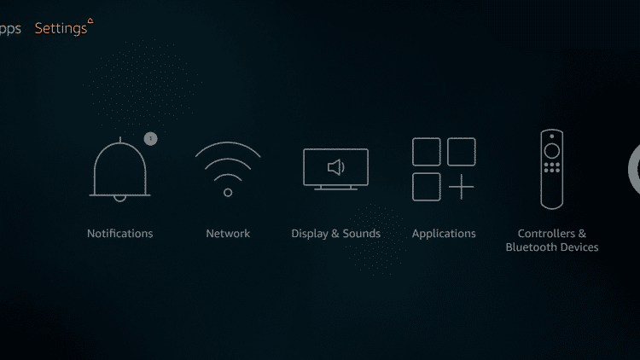
2. Click Device or My Fire TV
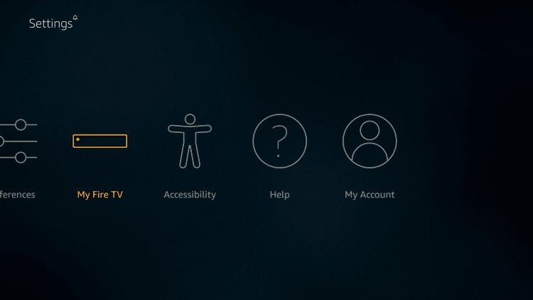

3. Choose Developer Options **If Developer Options isn’t Available Scroll to ABOUT and Select it 7 times and Developer Options Will Appear**
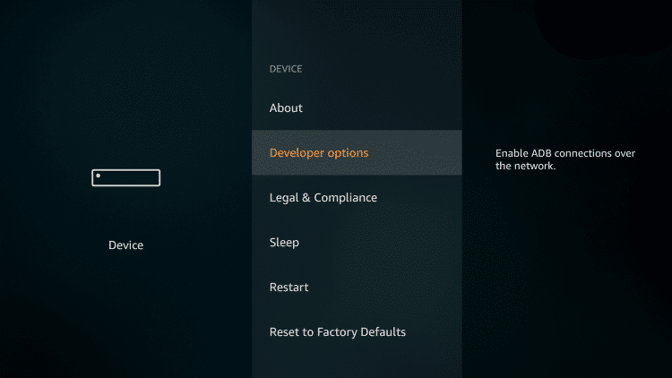
4. Click Apps from Unknown Sources
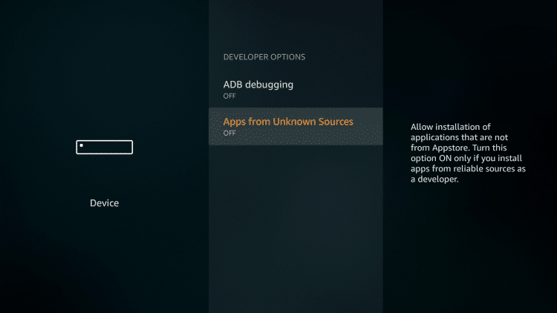
5. Choose Turn On
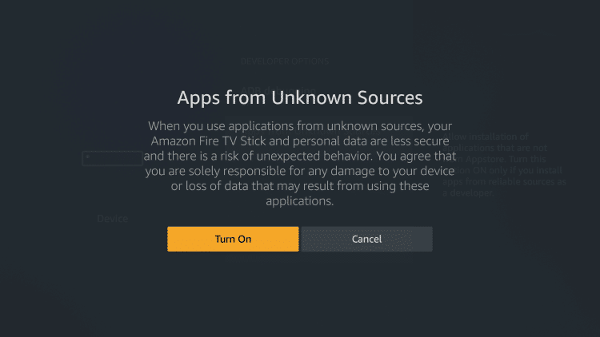
6. Return to the home screen and hover over the Search icon
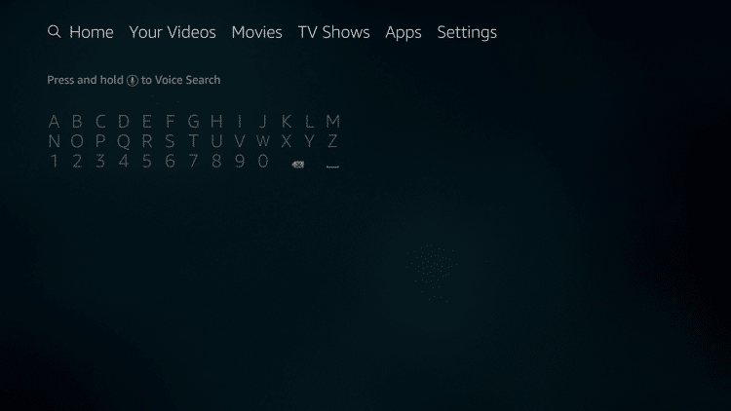
7. Type in Downloader and click “Downloader” which appears toward bottom in a list
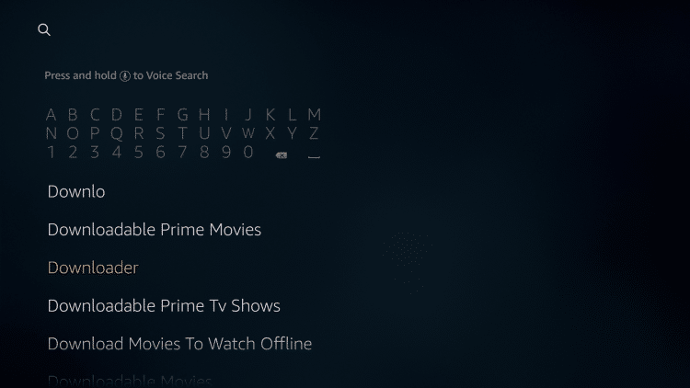
8. Select the Downloader app
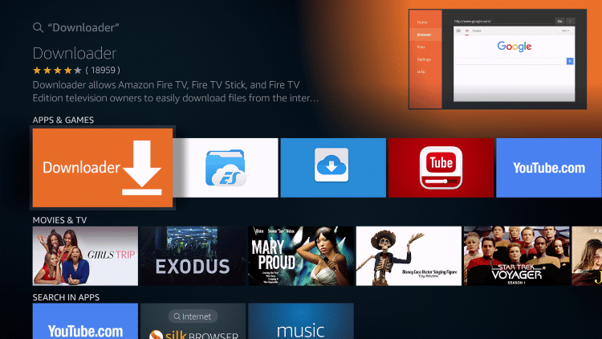
9. Click Download
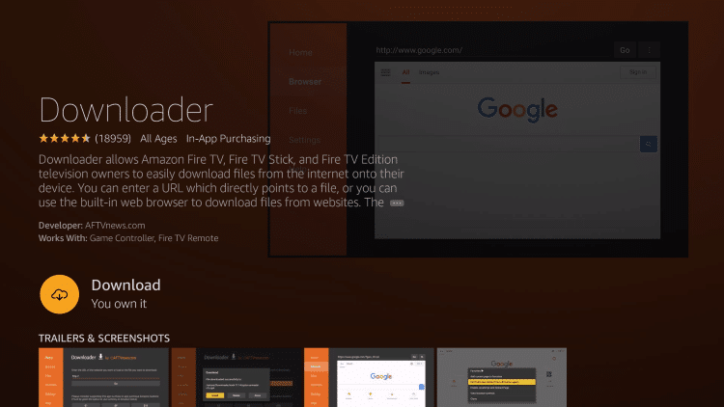
10. Click Open
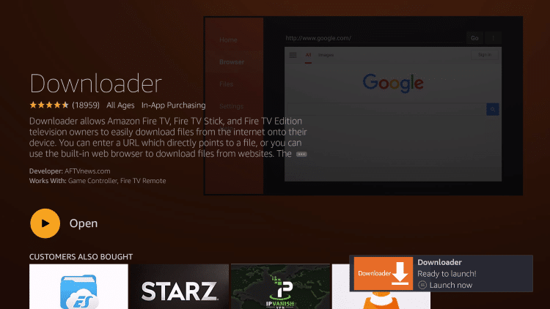
11. Click Allow
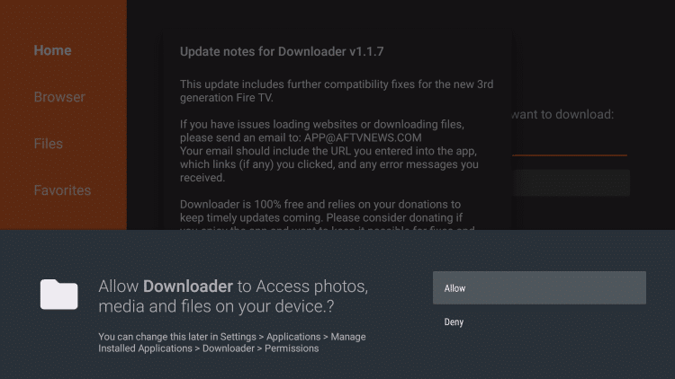
12. Click OK
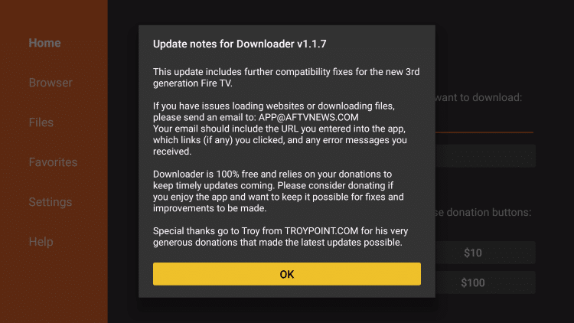
13. In the address bar, type the following URL:
TYPE in 76502 and you will have the options to click 803 Hosting Updated App.. Then Download it.

http://bit.ly/803hosting2 Updated Smart 803 Hosting Application
or
http://bit.ly/803hosting Original 803 Hosting Application

Pick one application or try out both to see which one you prefer

and click Go

14. Click Install
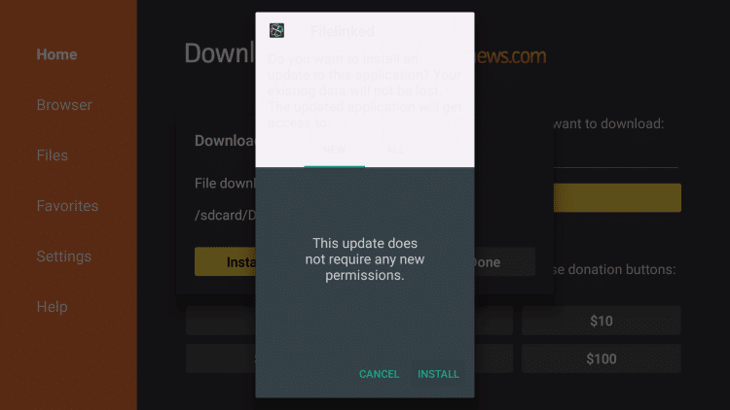
15. Click Done
803 Hosting TV App will be downloaded!!

Go to the site https://www.reese803hosting.com/ to pay bill if you want to continue service. Username will be sent.

